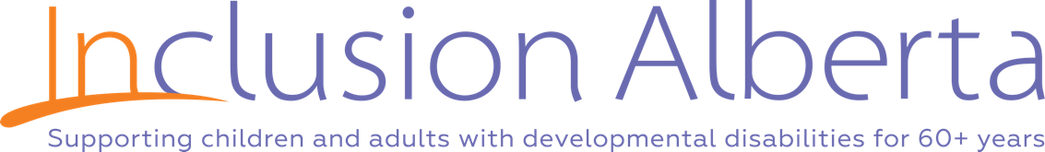
Job Title | Community Development Advocate – St. Paul, Elk Point, and Bonnyville
Reports to | Provincial Director of Advocacy and Community Engagement

Inclusion Alberta, as a family advocacy organization, is committed to providing individuals with developmental disabilities and their families with personalized advocacy that contributes to a meaningful and inclusive life.

Similarly, families and individuals with developmental disabilities, including those with complex needs, require assistance in planning and securing an inclusive life. Some of the means to an inclusive life include being able to maximally benefit from individualized funding and other funding and supports as needed to be engaged as a participatory and valued community member.

This position will be responsible under the direction of the Director of Advocacy to:
- provide individual advocacy to individuals with developmental disabilities and their families in the pursuit of a fully inclusive life in the community.
- guide the development of the Local Family Advocacy Organization.
Duties and Responsibilities:

Advocate:
- Work directly with individuals with developmental disabilities and their families to develop and articulate a vision for an inclusive life in the community and develop a plan to achieve this vision.
- Serve as a resource and guide to families and individuals with developmental disabilities to pursue support and services that enable inclusion.
- Support families to develop a network that shares their inclusive vision for their loved ones and supports their pursuit of inclusion.
- Advocate with and for families and individuals with developmental disabilities in their efforts to nurture and develop inclusive communities.
- Coordinate individual and family community engagement with all other Inclusion Alberta initiatives.
- Maintaining accurate records and reporting as required.
Local Association Coordination/Support:

- Guide and mentor the development of a local family advocacy organization, including the following:
  - Organize and coordinate regular meetings.
  - Work with the Local Association Board President to develop and draft agendas.
  - Prepare relevant updates and information to the Inclusion Alberta Executive.
  - Identify local trends and issues.
  - Collaborate with the Local Association to provide suggestions and recommend action.
  - Provide strategic advice.
  - Support and guide the Executive Board members to make sound and informed decisions.
- Research local trends; seek out resource support as necessary.
- Network/develop strategic relationships.
- Organize community engagement activities as agreed to by the Executive board members.
- Build a local membership base.
- Identify opportunities to increase the profile/identity of the Local Association.
- Help the Local Association Board members think about their various roles in the community and identify what action they could take to move inclusion forward and identify local priorities.
- Help the Executive board members plan for future autonomy from Inclusion Alberta that ensures their long-term viability and self-subsistence.
- Work with community organizations and businesses to enhance their capacity to facilitate the inclusion of children and youth with developmental disabilities.
- Establish partnerships with interested community organizations to facilitate inclusion and belonging.
- Prepare and submit required reports and updates.

Qualifications:

- A University degree in a related discipline or equivalent experience
- A deep understanding of inclusion and an unwavering commitment to its ideals
- Ability to facilitate collaboration across multiple community and government stakeholders
- Working knowledge of the systems and supports available to families and individuals with developmental disabilities in Alberta, particularly through the Ministry of Seniors, Community & Social Services, particularly FSCD, PDD and AISH
- Excellent organizational and interpersonal skills, and the ability to work independently as well as part of a team
- Excellent written and verbal communication skills; ability to communicate complex ideas in plain language
- Strong listening and problem solving skills
- Understanding of municipal, provincial and federal governmental responsibilities; interest in politics and how social change is effected
- Ability to manage competing priorities
- Desire to learn and a commitment to continuous improvement
- Ability to receive and incorporate feedback
- Strong understanding of inclusive education; previous experience working with schools is an asset
- Experience reading and interpreting legislation and policy is an asset
- Previous experience building community partnership is an asset

Working Conditions:

This position is located in St. Paul, Elk Point, and Bonnyville and supports Advocacy in the northeastern region of the province. Candidates will require a vehicle and the capacity to travel within Alberta regularly. This is a part-time position, and salary will be determined based on experience. Only candidates selected for interviews will be contacted. The competition will close once a suitable candidate is found.
Inclusion Alberta is committed to being a welcoming, inclusive, diverse, respectful, and equitable workplace. We welcome applications from all qualified persons and encourage women, First Nations, Métis and Inuit persons, members of visible minority groups, persons with disabilities, persons of all sexual orientations, gender identities and gender expressions to apply.

Please send a cover letter and resume to Catherine Oakleaf, with subject line Community Development Advocate – St. Paul, Elk Point, and Bonnyville to coakleaf@inclusionalberta.org

