How to sign up for the Community Helpers course
- Log on to Moodle, in the navigation pane click “courses”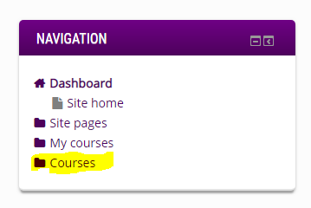
- Enter “Community Helpers” in the search bar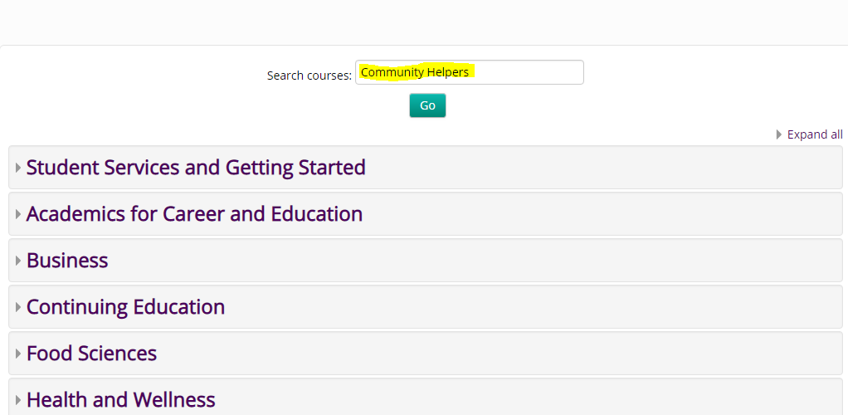
- Click on the Community Helpers course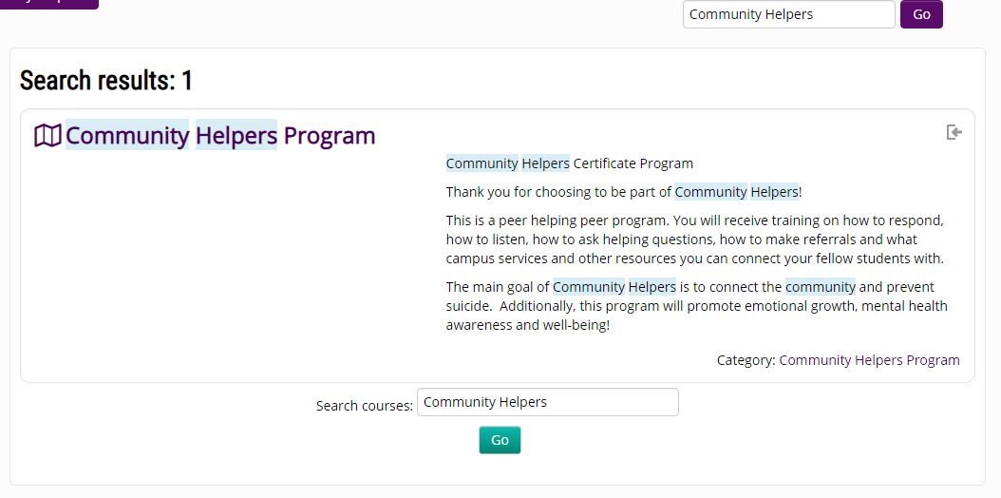
- Hit the “Enrol Me” button in the drop down menu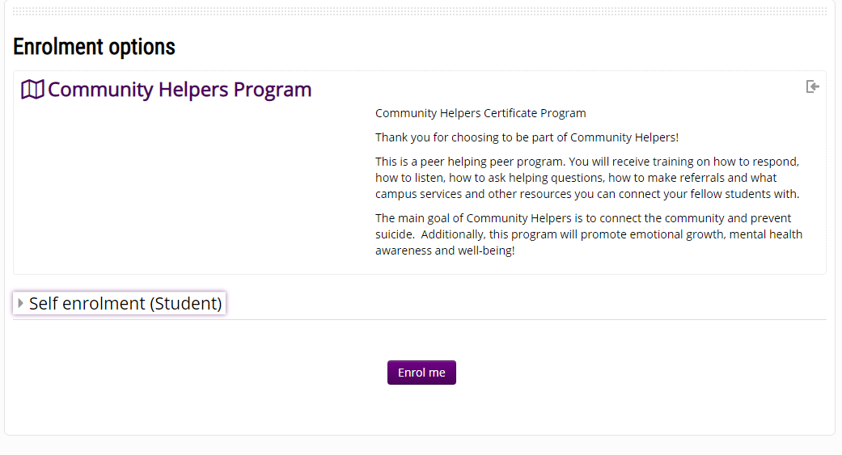
- You’re in!