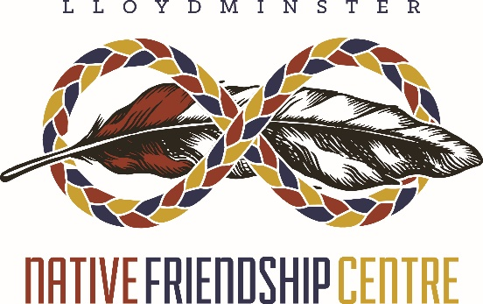
Box1364, 4602-49 Avenue

Lloydminster, AB/SK
S9V 1K4
Phone: (306) 825-6558
Fax: (306) 825-6565

The Lloydminster Native Friendship Centre, Inc. (LNFC) is currently accepting applications for the position of:
ACCOUNTING TECHNICIAN
Required an experienced Accounting Technician to provide administrative and bookkeeping support to the Executive Director in the following areas:
Administration:
- Record day to day financial transactions.
- Prepare financial reports as requested for review and reporting.
- Maintain filing system for all financial records,
- Research, develop and submit program applications and/or funding proposals to the Executive Director for review prior to forwarding to appropriate funding sources.
- Assist in development of program funding budgets monthly.
- Knowledge of Provincial/Federal Funding Agreements and Charity organizations (ANFCA Agreements)
- To help ensure project/program adherence to the terms and conditions of funding agreements.
- Other duties that are required by the Executive Director.
Required:
- Accounting/Finance experience minimum of 3-5 years.
- Accounting/Bookkeeping Training/Experience with SAGE50
- Proficient in MS Office, MS Word, and Excel
- Vehicle and Valid Drivers License.
- Criminal Records Check and Vulnerable Person’s Involvement Check.
Deadline for Application: OPEN FOR COMPETITION UNTIL SUITABLE CANDIDATE IS FOUND

Resume, including 3 references can be sent to:
Patsy Waskewitch, Executive Director
Lloydminster Native Friendship Centre
Box 1364, 4602-49th Ave.
Lloydminster, SK S9V 1K4
Fax:: 306-825-6565 email: execdirector@lnfc.org

